Cats vs Dogs Binary Classification - Project Report
Course: MLOps (S1-25_AIMLCZG523)
Institution: BITS Pilani
Project: End-to-End ML Model Development, CI/CD, and Production Deployment
Date: 6th January 2026

Contributors
Name | Bits ID | Contribution
Prasath J | 2024AA05323 | 100%
Vishwanath Rajakumar | 2024AA05309 | 100%
Adi Sathwik | 2024AB05213 | 100%
Jagadi Shruti Chanabasappa | 2024AA05181 | 100%
Kannan S | 2024AA05035 | 100%
GitHub Repository: Group_25_MLOps_Assignment2_CatsVsDogs

Executive Summary
Machine learning systems deployed in real-world environments must satisfy requirements beyond predictive accuracy. They must be reproducible, scalable, observable, and maintainable over time. MLOps provides a structured approach to address these challenges by integrating machine learning development with DevOps and data engineering practices.
This project presents a complete end-to-end MLOps pipeline for binary image classification (Cats vs Dogs). The implementation covers data ingestion, exploratory analysis, model training with PyTorch, experiment tracking with MLflow, CI/CD automation, containerization, Kubernetes deployment, and automated image updates, closely resembling industry-grade ML systems.
Key Achievements: - Implemented end-to-end MLOps pipeline for Cats vs Dogs image classification - Deployed containerized FastAPI service with Kubernetes manifests - Automated CI/CD pipeline with linting, testing, training, and image push to GHCR - Integrated MLflow for experiment tracking and model registry - Watchtower for automatic container updates when new images are pushed
Technologies Used: Python, PyTorch, MLflow, FastAPI, Docker, Kubernetes, GitHub Actions, Watchtower

1. Introduction

Problem Statement
The goal of this project is to develop a binary image classification model that correctly classifies images as either cats or dogs. In addition to building an accurate model, the system must support automated testing, containerized deployment, and automated infrastructure updates to ensure reliability in production environments.
Image classification is a fundamental computer vision task with applications in content moderation, pet recognition, and automated tagging. Deploying such models at scale requires a robust MLOps pipeline that ensures reproducibility and maintainability.

Objectives
- Build a production-ready ML model for Cats vs Dogs image classification using PyTorch
- Implement full MLOps pipeline (CI/CD, containerization, deployment)
- Set up experiment tracking with MLflow and automated model packaging
- Ensure reproducibility and scalability with Docker and Kubernetes
- Demonstrate industry best practices for ML system deployment

2. Dataset Description
The Dog and Cat Classification Dataset from Kaggle is used in this project. It contains images of cats and dogs suitable for binary classification.
Dataset Details: - Source: Kaggle – Dog and Cat Classification Dataset - Total Images (Raw): 24,998 - Classes: 2 (Cats, Dogs) – balanced - Train / Validation / Test Split: 80% / 10% / 10% - Target Image Size: 224 × 224 (RGB) - Format: Image files (e.g. JPEG/PNG) organized by class
The dataset is widely used for image classification benchmarks and provides a realistic setting for building and deploying a containerized ML service.

3. Data Acquisition and Exploratory Data Analysis

Data Acquisition
The dataset is obtained from Kaggle. Data acquisition can be automated using the Kaggle API or manual download, with scripts or documentation to ensure reproducibility. Raw images are organized into train/validation/test splits and resized to a consistent input size for the model.
Key steps: - Download dataset from Kaggle (API or manual) - Organize images by class (cats, dogs) and split (train/val/test) - Define target dimensions (224×224) for the CNN input

Data Cleaning and Preprocessing
Raw images are preprocessed to ensure consistent input for training and inference.
Preprocessing pipeline: - Resize: All images resized to 224×224 pixels (RGB) - Normalization: Pixel values normalized (e.g. to [0, 1] or standard ImageNet normalization) - Transforms: Applied via torchvision.transforms (Resize, CenterCrop, ToTensor, Normalize) for consistency between training and inference - Data validation: Checks for corrupt or missing files as needed
Preprocessing logic is encapsulated in the training and inference code so that the same transforms are applied at serving time.

Exploratory Data Analysis
Exploratory Data Analysis (EDA) was conducted to ensure data quality and justify preprocessing strategies.
Class distribution:
The dataset is perfectly balanced with approximately 50% cats and 50% dogs, mitigating class-based bias.
Visual analysis and dimensions:
(Screenshot required: eda_sample_images.png)
- Observations: Significant variance in lighting, background, and pose.
- Image dimensions: Most source images are larger than 224×224, justifying the down-sampling and resize strategy.
Environment setup:
Library | Version
Python | 3.11.x
PyTorch | 2.x (CPU)
MLflow | 2.x
FastAPI | 0.x

4. Feature Engineering and Model Development

Feature Engineering
For image classification, “feature engineering” is realized through image transforms and input normalization. All images are resized to 224×224, converted to tensors, and normalized. The same transform pipeline is used in training and inference to avoid train–serve skew.
Preprocessing steps: - Resize/CenterCrop to 224×224 - ToTensor and normalization (e.g. ImageNet mean/std or [0, 1]) - Pipeline is modular and reproducible across environments

Model Architecture: SimpleCNN
We implemented a baseline SimpleCNN using PyTorch for binary image classification.
Model components: - Feature extraction: Two convolutional layers (16 and 32 filters) with ReLU activation and MaxPool2d - Classification: Flattened feature map (32×56×56) followed by two fully connected layers (128 units and 2 outputs for binary classification)
This architecture provides a lightweight, CPU-friendly baseline suitable for containerized deployment.

Model Training and Evaluation
Model training is driven by a training script (e.g. src/train.py) that: - Loads data with the defined splits and transforms - Trains the SimpleCNN with configurable hyperparameters (learning rate, epochs, batch size) - Logs parameters and metrics to MLflow - Saves the best model (e.g. model.pt) to the MLflow artifact store
Evaluation is based on validation/test accuracy and, where applicable, other metrics (e.g. precision, recall) logged in MLflow.

5. Experiment Tracking with MLflow
MLflow was integrated to track experiments, hyperparameters, evaluation metrics, and trained model artifacts. Each training run is recorded for systematic comparison.
MLflow integration: - Tracking server: Hosted locally via Docker Compose (or file-based mlruns/) - Experiment name: e.g. “CatsVsDogs” or project-specific name
Logged information: - Parameters: Learning rate, epochs, batch size, model configuration - Metrics: Accuracy, loss (and any other metrics computed) - Artifacts: model.pt and related files saved to MLflow artifact store
This approach ensures reproducibility and provides an audit trail for all training runs.

6. Model Packaging and Reproducibility
The trained model is serialized (e.g. PyTorch state_dict or full model) and stored in MLflow. Dependency versions are captured in requirements.txt (and optionally in the Docker image) to ensure consistent execution.
Model serialization: - Best model saved as model.pt (or equivalent) and logged to MLflow - Loaded in the FastAPI app using the same architecture and preprocessing
Dependency management:
requirements.txt includes pinned versions for Python, PyTorch, MLflow, FastAPI, uvicorn, and other dependencies so the project can be reproduced from a clean environment.

7. CI/CD Pipeline and Automated Testing
Automated tests were implemented using Pytest to validate data loading, preprocessing, and model inference. The CI pipeline runs on every push/PR via GitHub Actions.
Pipeline stages: 1. Build environment: Creates a reusable Docker image with project dependencies 2. Linting: Runs Black and Flake8 for code style and adherence 3. Testing: Executes Pytest with coverage reporting 4. Training: Triggers model training and logs runs to MLflow 5. Deployment: Pushes the final Docker image to GitHub Container Registry (GHCR)
CI configuration is defined in .github/workflows/ci.yml with standardized paths and steps so that code quality and model artifacts are consistently validated before deployment.

8. Model Serving API
The trained model is exposed via a REST API built with FastAPI. The API accepts image uploads and returns class predictions.
API framework:
- Framework: FastAPI
- Port: 8000
- Command: uvicorn src.app:app
Endpoints: - GET /health – Health check; returns API and model loading status - POST /predict – Accepts an image file (e.g. multipart/form-data); returns prediction (cat/dog) and optionally confidence or probabilities
API features: - Input validation and error handling - Consistent preprocessing (same transforms as training) - Structured JSON responses
This design enables real-time inference and easy integration with downstream applications.

9. Containerization and Deployment
The application is containerized using Docker and can be deployed to Kubernetes for scalability and high availability.

Docker Configuration
- Base image: python:3.11-slim
- Port: 8000
- Commands: uvicorn src.app:app (or equivalent entrypoint)
Build and run: - docker build -t cats-dogs-api . - docker run -p 8000:8000 cats-dogs-api

Kubernetes Orchestration
Deployment manifests (deployment.yaml and service.yaml) define: - Replicas: 2 for high availability - Rolling updates: Smooth transitions when a new image is deployed - Health checks: Liveness and readiness probes enabled
Deployment steps: build image, push to GHCR, then kubectl apply -f k8s/ to deploy.

10. Monitoring and Logging
API endpoints:
- Health check: GET /health
- Inference: POST /predict (accepts image upload)
Automated updates:
Watchtower is integrated into the Docker Compose setup to monitor GHCR and automatically pull and restart containers when a new model image is pushed. This reduces manual intervention for model updates.
Logging can be extended to capture request metadata and prediction results to stdout or a logging backend for debugging and operational analysis.

11. Architecture Overview
The system architecture integrates data ingestion, model training with MLflow tracking, CI/CD automation, containerization, Kubernetes deployment, and automated image updates into a single pipeline.
Architecture components: 1. Data layer: Dataset acquisition (Kaggle), preprocessing, and train/val/test splits
2. Training layer: PyTorch SimpleCNN training with MLflow tracking
3. CI/CD layer: GitHub Actions (lint, test, train, push image to GHCR)
4. Containerization: Docker image with app and model
5. Deployment layer: Kubernetes orchestration (deployment + service)
6. API layer: FastAPI service for health and prediction
7. Update layer: Watchtower for automatic container updates from GHCR
This reflects an MLOps workflow suitable for production-style deployment of image classification models.
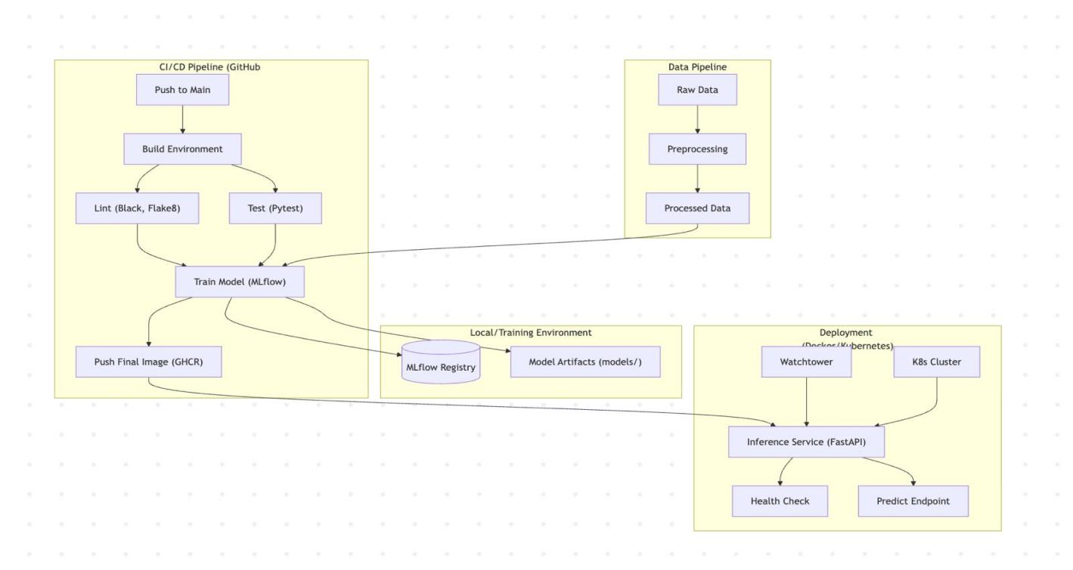

12. Conclusion
This project demonstrates the application of MLOps principles to build a reproducible and deployable image classification system (Cats vs Dogs). By automating training, testing, deployment, and container updates, the pipeline supports long-term maintainability and scalability.

Key Achievements
- Successfully implemented an end-to-end MLOps pipeline for binary image classification
- Containerized FastAPI service with Kubernetes manifests for scalable deployment
- Automated CI/CD ensures code quality and reproducible model builds
- MLflow integration provides experiment tracking and model versioning
- Watchtower enables automatic container updates when new images are pushed to GHCR

Challenges and Mitigations
Challenge | Mitigation
Docker image size | Use python:3.11-slim and CPU-only PyTorch builds
CI path errors | Standardize paths in .github/workflows/ci.yml
Inference latency | Optimize preprocessing using torchvision.transforms

Future Improvements
- Add Prometheus/Grafana (or similar) for metrics and dashboards
- Implement A/B testing or canary deployments for model updates
- Add model explainability (e.g. saliency maps) for interpretability
- Extend to GPU-based inference for higher throughput
The solution satisfies the assignment requirements and aligns with industry best practices for MLOps and ML system deployment.

References
- Kaggle – Dog and Cat Classification Dataset
- MLflow Documentation
- FastAPI Documentation
- Docker Documentation
- Kubernetes Documentation
- GitHub Actions Documentation
- PyTorch Documentation

Appendix A: Repository Structure
Group_25_MLOps_Assignment2_CatsVsDogs/
├── data/ # Dataset (e.g. DVC or local)
├── notebooks/ # Jupyter notebooks (EDA)
├── src/ # Source code
│ ├── train.py # Training script
│ ├── app.py # FastAPI application
│ └── ... # Model and preprocessing modules
├── tests/ # Unit tests (pytest)
├── k8s/ # Kubernetes manifests
│ ├── deployment.yaml
│ └── service.yaml
├── reports/ # Report documents
├── .github/workflows/ # CI/CD pipeline (ci.yml)
├── docker-compose.yml # Local stack (API, MLflow, Watchtower)
├── Dockerfile
├── requirements.txt
└── README.md

Appendix B: Setup Instructions
Detailed setup instructions are available in the main README.md. Key steps:
- Clone the repository
git clone https://github.com/kannans/Group_25_MLOps_Assignment2_CatsVsDogs.git
- Install dependencies
pip install -r requirements.txt
- Obtain dataset
Download from Kaggle (Dog and Cat Classification Dataset) and place in data/ or configure DVC.
- Train model
python -m src.train (or as specified in README)
- Run API locally
uvicorn src.app:app --reload
- Build and run with Docker
docker build -t cats-dogs-api .
docker run -p 8000:8000 cats-dogs-api
- Deploy to Kubernetes
kubectl apply -f k8s/
For full details, see README.md and any k8s/README.md in the repository.
End of Report

